Webster PAC Meeting Sept 25/25 AGENDA | 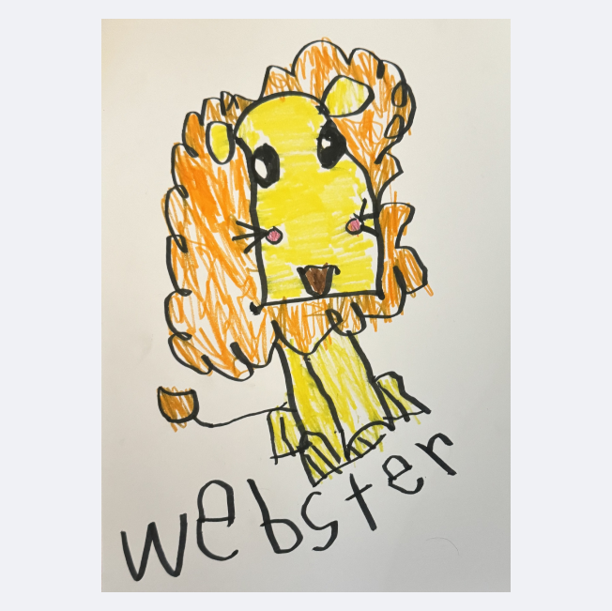
In Attendance: Mark, Carla, Leanna, Tamerra, Heather, Floyd, Marley, Dekota, Tas, Kendra, Shelly
- Call to order 7:02 pm
- Land Acknowledgement - Honouring and acknowledging the traditional territory of the Sinixt, Ktunaxa and Syilx Peoples, the land where we live, learn, work and play while also working to strengthen our relationships with the Métis and the Inuit peoples in our community.
- Approval of Past Meeting Minutes
    - Approval of minutes next meeting.
    - Mov:Sec: {Name}
- Safe School Issues
- Angela Weeks- unable to attend but asking if anyone will join her at the Village Council meeting Oct 14 as she is raising safety concerns for the Bingay Rd crosswalk.
  - Mark to draft letter to Teck and transporters. Mark might be able to attend the village meeting.
- Bikes on bike rack
  - Reminder to kids to lock bikes up and bring helmets.
- Radar Activated Strobe Light
  - The LR-15 is mounted with your standard speed limit sign. The LR-15 comes with a pair of LED beacons that will flash in 1 of 7 patterns to draw the driver’s attention to the speed limit sign if they are travelling over the speed limit. The radar head, electronics and batteries are housed in a tough pelican style housing. The free LR-15 scheduling software will allow you to program the LR-15to be active all the time, or just on days and times when you want to alert drivers. Perfect for school or park zones.
The LR-15 will also collect all the data you need and can be easily displayed in any spreadsheet.
- Vehicle Count
- Speed
- Time of Day
- Class of Vehicle

- Reports
Principal Report
  - Shelly presented the report, and is attached.
  - School Enrolment/Configuration Update – 239 students in 11 divisions.
  - Information on the School District Website on Combined Classes – under the Parent tab.
  - Grow Towers (4) and Green house
    - Open to Selling the grow towers.
    - Use funds to get composters.
    - WES requested the removal of the Greenhouse.
      - Motion: Offer the greenhouse (If owned by PAC), to the community member who asked to buy it.
        - Mover: Tamarra Second:
    - Keep using green boxes.
  - Kootenay Columbia School District Strategic Plan – what this means for Webster
    - Working on Numerace, and belonging.
  - Support request for 2025/2026
    - Winter Wonder
    - Ski Days - cost is now over $80 a day for a full package (two times)
    - Primary Skate
    - Grade 7 trip to Pines in the Spring
    - Swimming
    - New Jerseys
    - Other options?
  - Food Program
    - Once a month a hot breakfast for all students who want it.
      - The need is for volunteers needed to help make the food.
  - Info for WES Newsletter.
  - Need for coaches for Volley Ball/Basketball
    - Crim record check
    - 1.5 hr 2 times per week.
    - Tass to make some calls.
Village Liaison Report: Deb Penner not in attendance.
  - Nightmare on Lauriente Way on Oct 25

School Health- Public Health Nurse: None

Trustee Report- None

DPAC Report:
Vote on DPAC Rep:
Carl Nominated and Acclaimed.
  - Advocacy
    - Advocacy Program Workshop hosted by BCCPAC Sept 24 6:30pm via Zoom
  - Policy:
    - Policy Review out on code of conduct.
    - Strat plan video- ATTACH HERE
  - Budget
    - Had a surplus. Can see it on the website.
    - Close to 5000 kids less than last year.
  - DPAC Projects
    - Glenmerry is open, and has had a water meeting.
    - DPAC AGM Oct 21st.
Motion to Receive the above reports.
Mov:TamarraSec: Heather
- Financials
Treasurer Report: As of Sept 25/25

Chequing Account: $9482.19 available balance
Projects Account Available: $3 981.82
Gaming Account: = $2 084.68 Available balance
*Playground fund: $8,152.00 remaining - to use for outdoor classroom supplements once the district has a base plan in place. (held in trust with the school district)

Transactions: Sept 1 – Sept 25

Payee | Withdrawal/Deposit | Amount | Account | Comments
Mills | Withdrawal | 364.25 | chequing | School supplies
Pango | withdrawal |  | chequing | AGM Pizza

Motion to Receive the treasurer Report.
Mov:Carla Sec: Mark

- Fundraisers:
Name: Ferraro Foods Gift Cards
Start Date: Oct 14th
End Date: Oct 24th
Pick up: Oct 29th
Delivery: Oct 30th
Profit:
Notes: Pick up and distribution is still a risk. Add a check box to put them in your backpack.

Name: October Pizza Day-Oct 16th (second thursday of the month)
Start Date: Oct 1st, 2025
End Date: Oct 9th, 2025
Profit:
Notes: Tass and Leanne

- Correspondence:
  - BCTF Magazeen
  - Cheque from Mabel's label.
- Old Business
- ICBC grant- Report located.
- Story Walk
- Student Art Display locations: KSCU Trail, Evergreen Sports Therapy, A&J Car Repair, Marino’s, Village of Warﬁeld ofﬁce, Gypsy Soul Hair (doesn’t even exist anymore…) Ok Tire, PetroCan, Trail & District Public Library, RCMP Trail detachment, Warﬁeld Council chambers, Zee Crepes
- Purchase hand soap for next year’s Pancake breakfast, another griddle and ﬂippers?

- New Business
  - Events to support this year
    - Movie in December
      - PAC to send dates and movie ideas to Shelly.
    - Winter Wonder for Primary
    - Skate with Smokies for Primary
    - Ski days for Intermediate
    - Ice cream for Sports Day
    - Pancake Breakfast for Pink Shirt Day
    - District Track Meet
      - Tent and jersey
    - Indigenous People’s Day
    - Support offer to Miss. Tally
    - Webster Grad Bursary
    - Carnival in February
    - Smokies in our School
      - Rally towels
    - Swimming in June
    - Year End field trips
    - Grade 7 Trip
  - Budget for 2025/26
    - Mark to create a draft budget with Heather.

  - Which fundraisers do we want to do this year?
    - Ferraros- Carl to share dates
    - Pizza Day- Leanne to send dates to be included.
      - Dates:
    - 2 Book Fairs
      - 1st - oct 20-22
      - 2nd -?
    - Apple Fundraiser
    - West Coast Seeds - January delivery.
    - Created by Kids Greeting/Holiday Cards
      - Send the form home, just christmas cards.
      - Look into the cost. - Tamarra
    - Purdy’s Christmas and Easter - yes
    - Growing Smiles Winter and Mother’s Day
      - Heather to ask about minimums.
      - Nov 4th order deadline
      - Delivery Nov 18th
    - Pride Wear Fall & Spring
    - Mabels Labels on going
    - TruEarth on going
    - Halloween candy purchase
    - Participaction Grant
  - Halloween Dance after Nightmare on Lauriente
    - Work with Warfield YAN?
    - Tammara looking into this.
  - Fall Bookfair Oct 20-22
    - On the stage in the fall.
    - Set up on the Oct 17th @ TBD
    - Take down on Oct 22nd @ 4:00PM
  - Gaming Grant Summary- Heather
  - Dance & Cantina- Mark
    - No dance at WES this year
  - BCCPAC Registration fee $100
    - Moved: Carla Second: Tammara
  - Grow Towers- do we want to sell them?
    - Tammar to get a price.
    - Mark Knows someone who might want.
  - Miss Tally has her own classroom now! Support for her & Indigenous Services
    - Heather to ask Miss Tally what she needs.
  - New PAC merch with new logo?
    - Notes Move to Oct meeting
  - PAC dates for the year: Oct 16, Nov 13, Dec 11, Jan 15/26, Feb 12, Mar 12, Apr 16, May 14 or 21, June 11
    - Moved to October.
  - Pay Carla for the Pizza for AGM $59.06
    - Move: Leanne Second: Heather
- Action Items
Items | Person Responsible | Due Date | Notes

- Motion to Adjourn.
Mov: Carla
Next Meeting October 16, 6:30pm
Webster Staff Room

