Webster PAC Meeting Oct16/25 AGENDA | 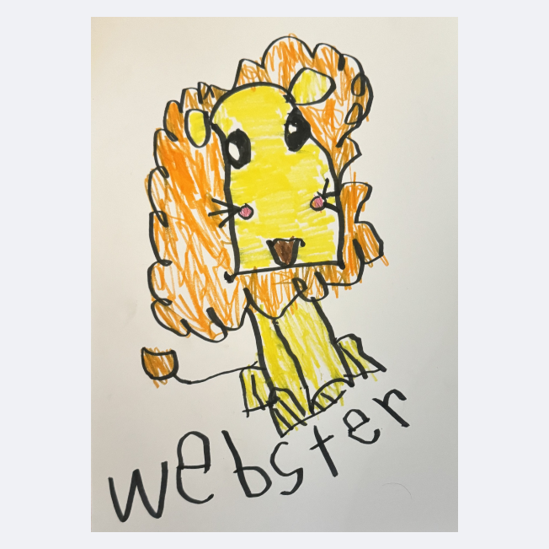
In Attendance: SHelly, Tammerra, Leanna, Heather, Carla, Tes, Marly, Mark (Arrived at 6:45)
- Call to order 6:30pm
- Land Acknowledgement - Honouring and acknowledging the traditional territory of the Sinixt, Ktunaxa and Syilx Peoples, the land where we live, learn, work and play while also working to strengthen our relationships with the Métis and the Inuit peoples in our community.
- Approval of Past Meeting Minutes
    - Approval of minutes from June 2025
    - Mov:Sec: {Name}
    - Approval of minutes from September 2025
    - Mov:Sec:{Name}
- Safe School Issues
- Intruders in the school

- Reports
Principal Report - Report Attached
Ski days are $80/day Wondering if PAC can support skiing.
Carl - Is a payment plan an option. Shelly does not know if that is an option.
PAC could use hot lunch to set up a payment plan.
Leanna looked at KSCU for a grant.
Hot breakfast volunteers needed for 7:00 AM once a month. PAC will add the call to our facebook page.
Village Liaison Report: Deb penner regret.
PAC will run concessions, decorate and clean up. Need volunteers

School Health- Public Health Nurse:
- Annual Anaphylaxis training was provided to Webster teachers by Public Health on October 7th.
- Grade 6 Immunizations will be utilizing a digital consent form to parents for the first time this year. Immunization date will be in the new year.
- Public Health is available to support school staff and the PAC with Health Promotion activities as requested. Link to the IH website with resources and information on services: School Staff | Information For | IH

Trustee Report: None

DPAC Report: AGM on Tuesday October 21, 2025

  - Advocacy

  - Policy:

  - Budget

  - DPAC Projects

Motion to Receive the above reports.
Mov: Tammerra Sec: Leane
- Financials
Treasurer Report: As of Sept 25/25

Chequing Account: $12,174.33 available balance- (Panago, Mark, Heather, Gala Apples)
Projects Account Available: $3 981.88
Gaming Account: = $6 804.70 Available balance
*Playground fund: $8,152.00 remaining - to use for outdoor classroom supplements once the district has a base plan in place. (held in trust with the school district)

Transactions: Sept 1 – Oct 16

Payee | Withdrawal/Deposit | Amount | Account | Comments
Mills | Withdrawal | 364.25 | chequing | School supplies
Carla Plotnikoff | withdrawal | 59.06 | chequing | AGM Pizza
Mark Stephens | withdrawal |  |  | Open House coffee/Bubly
Heather Bishop | withdrawal |  |  | Open House cookies, Gala Apples
BCCPAC | withdrawal | 100.00 | gaming | Membership dues-e transfer sent
Webster PAC | Deposit | 4820 | gaming | Gaming Grant
Panago | withdrawal |  |  | October Pizza Day
Marinos | withdrawal |  |  | October Pizza Day
GF Farms | withdrawal | $259 | chequing | Apples e-transfer sent

Motion to Receive the treasurer Report.
Nov: Mark Sec: Leanne

- New Business
  - Gaming Grant came in- $4 820.00
  - Movie in December- 2 different days for primary/intermediate would be helpful
      - Available dates Dec 9/10/12. Will require us to put a $100 deposit per booking. Feedback is 9th and 10th are the best day.
      - Snacks for students $6.65 + tax =small juice, mini popcorn and Halloween candy. (Lisa says all other schools do this) $1,582.70 total.
      - Busing availability will determine the timing.
      - PAC buys cookies and chocolate milk.
      - Shelly will look into bussing.
      - Motion to book theater for Dec 9th and 10th

  - Budget for 2025/26
    - Mark to create a draft budget with Heather.
    - To Continue.
  - Book fair- so many volunteers!
    - PAC to cover $9 primary and $10 intermediate.
    - Set up Book Fair Oct 17th
    - New ideas for Spring book fair.
  - Created by Kids Greeting/Holiday Cards
    - We have enough we will pass for this year.
  - Growing smiles are ready to go up. Heather will send info to Pac email and get it put in the newsletter.
  - West Coast Seeds - earliest campaign start date is Dec 15, with delivery at the end of January. Do we want to apply?
    - WIll launch it on December 15th. And keep it open over christmas.
  - Grow Towers
    - NewTower $965, New lights $416.
    - Sell for $600.
  - Green House- purchased by PAC (along with pavers, fencing and garden beds) for $4 456.48 in 2015.
  - Oct 25 Dance shifts, sign up email sent out to Executive only but Facebook post asking for volunteers done.
    - Ordering from Marinos, what/how much.
      - Chips: plain, all dressed, deritos. 150 bags total Leanna to order.
      - Lemonaid: cups and mix.
      - Candy: 3/$1
  - New PAC merch with new logo? T Shirt for Bryden Taks

  - Motion for logo: keep logo as is without the “promoting webster’s pride”
    - Mover: Mark Second: Leanna
  - PAC dates for the year: Nov 13 @ 6:00pm, Dec 4@ 6:00pm, Jan 15/26@ 6:00pm, Feb 12@ 6:00pm, Mar 12, Apr 16, May 14 or 21, June 11

- Fundraisers:
Name: Gala Apples
Start Date: Sept 15/25
End Date:Oct 10/25
Profit: $185
Notes: Apples dropped off at Tamerra’s

Name: Ferraro Foods Gift Cards
Start Date: Oct 14th
End Date: Oct 24th
Pick up: Oct 29th
Delivery: Oct 30th
Profit:
Notes: Pick up and distribution is still a risk. Adults must indicate if they would like cards sent home with students. The default is to pick up at the school (where from?)

Name: Fall Pride Wear
Start Date: Oct 13th
End Date: Nov 3rd
Delivery: End of November
Profit:
Notes:

Name: November Pizza Day - Nov 13
Start Date: October 29th
End Date:November 6th
Profit:
Notes:

Name: Growing Smiles Winter Campaign
Start Date:
End Date: Nov 4/25 with Delivery on Nov 18
Profit:
Notes:

Name: Purdy’s Holiday Campaign
Start Date:
End Date: Nov 25 with pick up by Dec 8
Profit:
Notes:

Name: Ferraro Foods Gift Cards
Start Date: Nov17th
End Date: Nov 24th
Pick up: Nov 29th
Delivery: Nov 30th
Profit:
Notes: Pick up and distribution is still a risk. Adults must indicate if they would like cards sent home with students. The default is to pick up at the school (where from?)
- Correspondence:
  - Letter from KSCU.
    - Need to review scout type and documentation to keep preferred monthly pricing.
- Old Business
- ICBC grant- Report located.
- Story Walk
- Student Art Display locations: KSCU Trail, Evergreen Sports Therapy, A&J Car Repair, Marino’s, Village of Warﬁeld ofﬁce, Gypsy Soul Hair (doesn’t even exist anymore…) Ok Tire, PetroCan, Trail & District Public Library, RCMP Trail detachment, Warﬁeld Council chambers, Zee Crepes
- Purchase hand soap for next year’s Pancake breakfast, another griddle and ﬂippers?

.

- Action Items
Items | Person Responsible | Due Date | Notes
Float for book fair | Tamerra & Heather | Oct 22
Float for Concession | Tamerra & Heather | Oct 24
Budget 2025/26 | Mark and Heather | November 13

- Motion to Adjourn.
Mov: Carla
Next Meeting Nov 13, 6:00pm
Webster Staff Room

